Session 1
Q1. Write a short paragraph in your own words defining what a 'program' is and give one real-life example from any app you use daily (like Instagram, Zomato, or Paytm).
Ans: A program is a set of instructions written in a programming language that tells a computer what to do. It helps perform specific tasks automatically and solves problems efficiently. For example, when I use Instagram, the program allows me to log in, view posts, like photos, send messages, and watch reels based on my interests.

Q2. List three popular programming languages you have heard of, and for each, mention whether it is usually compiled, interpreted, or can be both.
Ans: 1. C – Usually Compiled.
2. Python – Usually Interpreted.
3. Java – Both (compiled into bytecode and then interpreted/JIT-compiled by the Java Virtual Machine).

Q3. Draw a flowchart (on paper or using any online tool) for the process of booking a movie ticket on BookMyShow, starting from opening the app to receiving the booking confirmation.
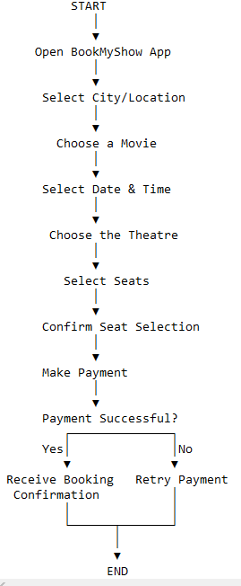
Ans:

Q4. Write down the steps (as an algorithm, using simple numbered instructions) for ordering food on Swiggy — from opening the app to completing payment.
Ans:
1. Start.
2. Open the Swiggy app.
3. Log in to your account (if required).
4. Enter or confirm your delivery location.
5. Search for a restaurant or food item.
6. Select the restaurant.
7. Choose the food items you want to order.
8. Add the selected items to the cart.
9. Review your order and click Proceed to Checkout.
10. Select or confirm the delivery address.
11. Choose a payment method (UPI, Card, Net Banking, or Cash on Delivery).
12. Complete the payment.
13. Receive the order confirmation.
14. End.

Session 2
Q1. Install GCC on your computer and verify the installation by running gcc --version in your terminal or command prompt.
Ans:

Q2. Open VS Code or DevC++ and create a new file named hello.c. Write a C program that prints 'Hello, Instagram World!' to the console.
Program
#include <stdio.h>
int main()
{
printf("Hello, Instagram World!");
return 0;
}
Output:
Hello, Instagram World!

Q3. Identify and label the header, main function, and return statement in your hello.c program using comments.
Ans:
// Header File
#include <stdio.h>
// Main Function
int main()
{
printf("Hello, Instagram World!");
// Return Statement
return 0;
}

Q4. Compile your hello.c file using the GCC command line (gcc hello.c -o hello) and run the output file to display the message in your terminal.
Ans:

Session 3
Q1. Declare variables for a Flipkart product: productName (as a string), price (float), and rating (double). Assign sample values and print each variable with its data type.
Ans: task1.cpp

Q2. Create a constant variable to store the GST rate (for example, 18%) and use it to calculate the final price of a Zomato order with a given base price.
Ans: task2.cpp

Q3. Write a program that stores your favorite Spotify playlist's name (string), total number of songs (int), and average song duration in minutes (float). Print all values in a single formatted sentence.
Ans: task3.cpp

Q4. Identify and correct the invalid variable names from this list: 1stPlayer, player_age, $score, total-marks, userName.
Ans: 1. 1stPlayer – Invalid (variable names cannot start with a number)
Correct: firstPlayer or player1
2. player_age – Valid (underscores are allowed)
3. $score – Invalid (the $ symbol is not allowed in C variable names)
Correct: score
4. total-marks – Invalid (hyphens - are not allowed because they are treated as the subtraction operator)
Correct: totalMarks or total_marks
5. userName – Valid (starts with a letter and uses only letters)

